Assignment 6

Q1. WAJP for AND && operator

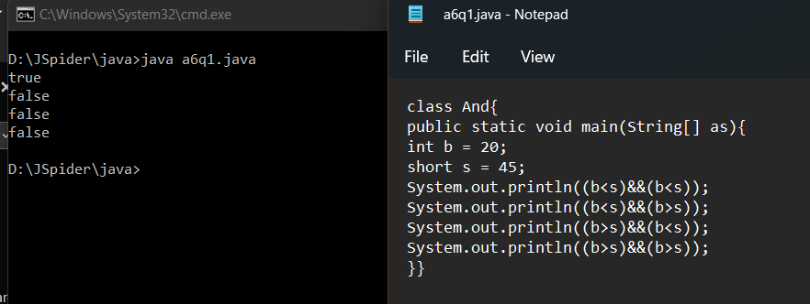

Q2. WAJP for OR || operator

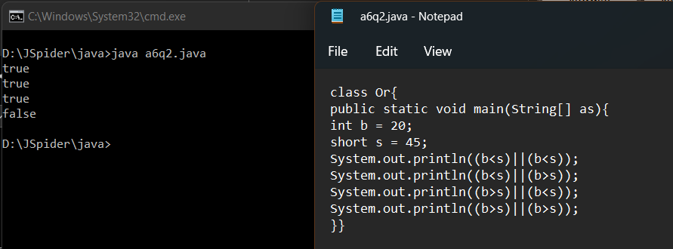

Q3. WAJP for NOT ! operator

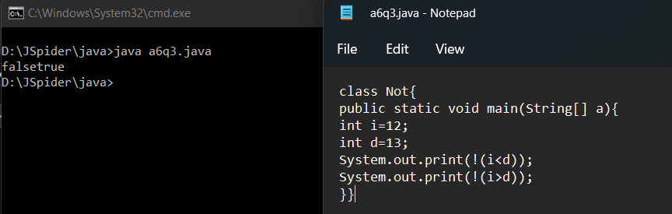

Q4. Trace the program

int a =20;

a++;

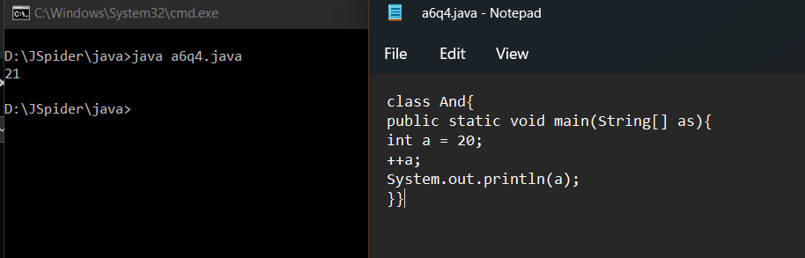

Q5. Trace the program

int b =20;

++b;

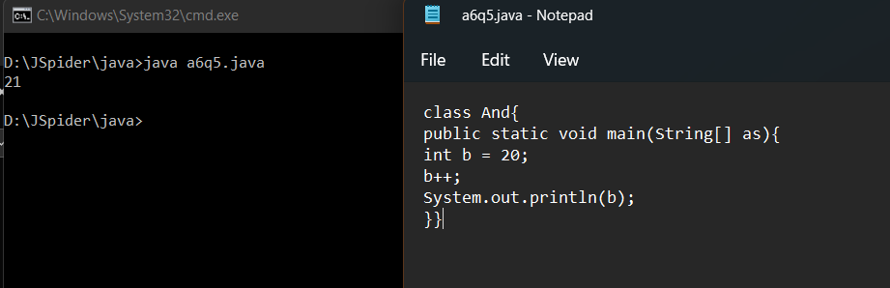

Q6. Trace the program

int a =20;

a=a++;

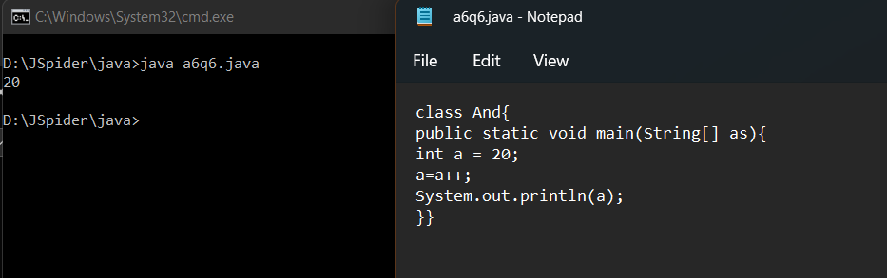

Q7. Trace the program

int d =20;

int e =30;

d= d++ + ++e;

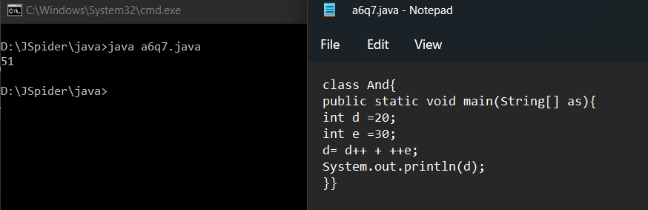

Q8. Trace the program

short s =20;

byte b =30;

s++;

++b;

System.out.println(s+b);

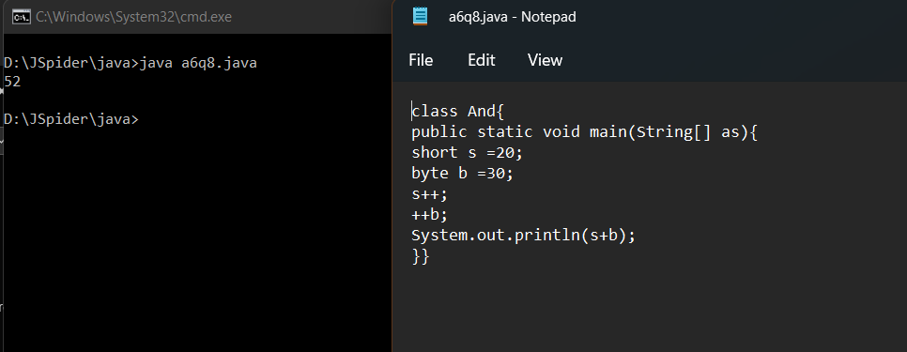

Q9. Trace the program

int a1 = 100;

short a2 = 150;

int a3 = 350;

long a4 = 200;

int res = a1++ - ++a2 + a3++ - ++a4;

